AirRoad Linehaul Services – 2023-2024 Holiday Season

Services for Christmas and New Year
As the holiday season approaches, we’d like to take this opportunity to thank you for your continued business. It is business associates like you who make our jobs a pleasure and keep our business successful.
May your holiday season and the New Year be filled with much joy, happiness, and success. We look forward to working with you in the coming year and hope our business relationship continues for many years to come.

Transit Times (schedule attached)

Transit times may vary slightly over the Christmas period especially for remote areas.
Regional Victoria: Our reginal network will not operate the week between Christmas and New Year (27th, 28th and 29th) All freight will be held in Melbourne on Friday 22 December, with the next linehaul leaving Tuesday 2 January.

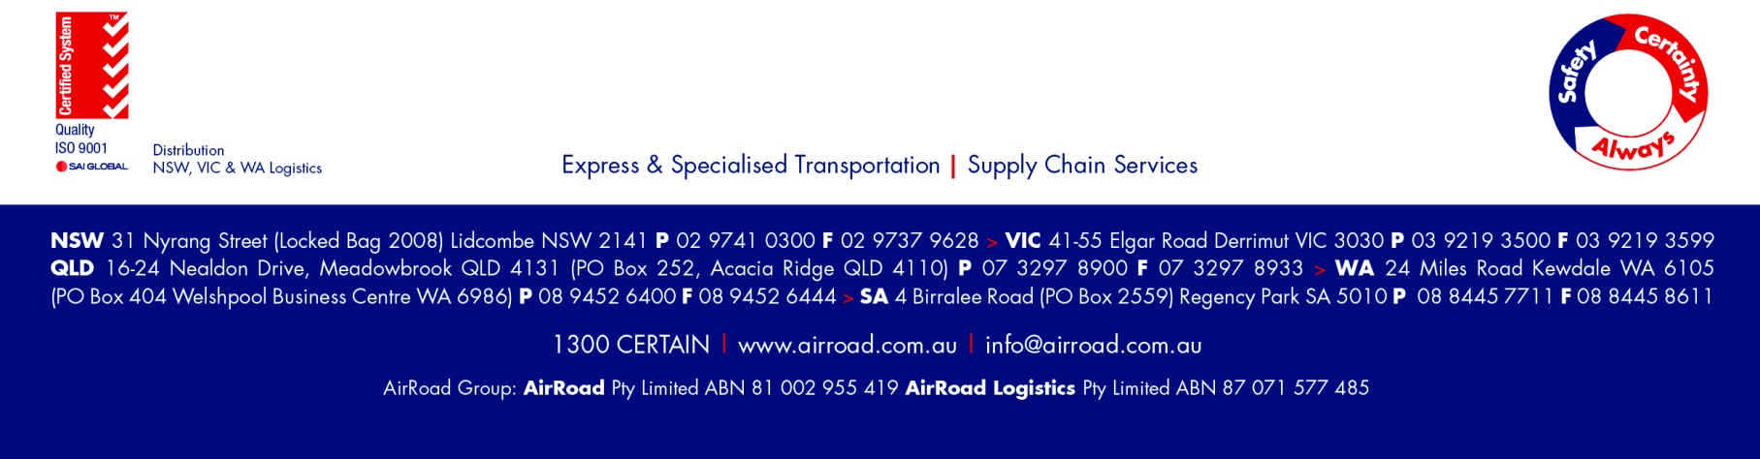
All linehaul will return to normal from Tuesday 2 January 2024.

Christmas / New Year Metro: Pick Up & Delivery Timetable

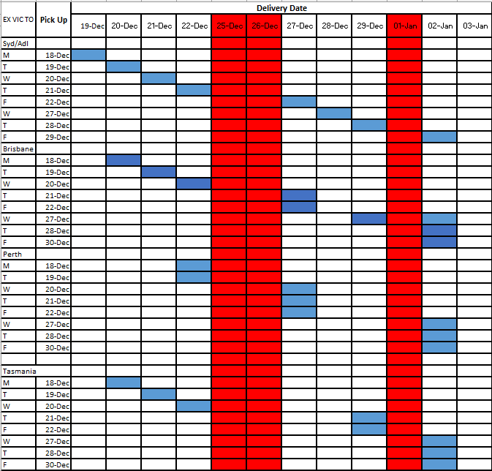

- Please Note - Some variations may occur, please contact us if you have any questions or have a specific requirement during this period.

